18B 中段考 写作题 两题

第一篇按照说明文一般打分公式，字数为200字以上，不够扣分

第二篇按照记叙文一般打分公式，字数为350字以上，不够扣分

提交期限为： 11月3号

1. 图表题

题目要求：The chart below shows the relation between stress and health and performance. Please summarise the information by selecting and reporting the main features, and make comparisons where relevant. Your writing should be of no less than 200 words.

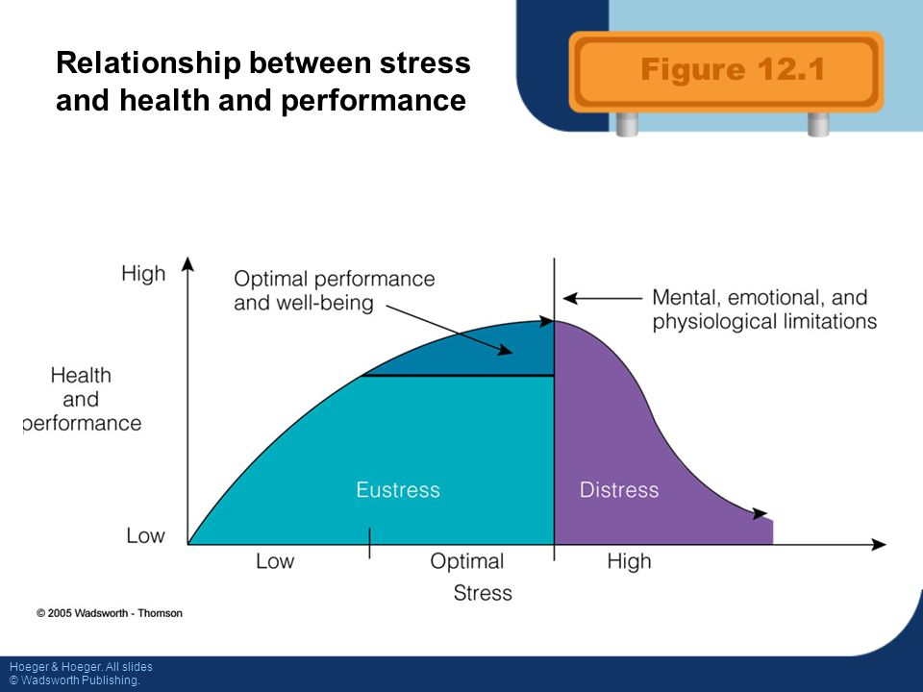

2. 记叙文

题目要求：Chapter 3 discusses biological, psychological and social changes one may experience in school and in family during his or her teen years. In family, what kind of parenting do you have or do you approve of? What kind of parenting do you believe is best？Please relate to your own experience and write on the topic of ***parenting and teen development***. Your writing should be of no less than 350 words.